82nd Fleet Reserve Association and
80th Auxiliary of the FRA
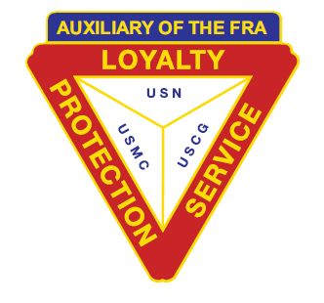
East Coast Regional Convention
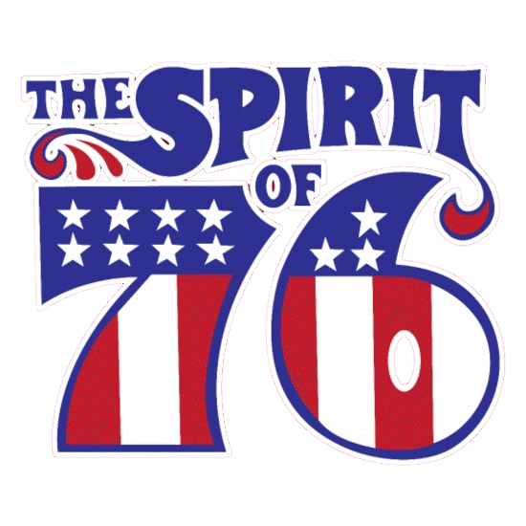
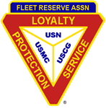

Happy 250th USA
Hilton Garden Inn Richmond Innsbrook
4050 Cox Rd, Glen Allen, VA 23060
July 23, 2026 to July 26, 2026

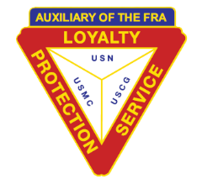

82nd FRA and 80th Auxiliary of the FRA
East Coast Regional Convention
Newsletter #1 March 2026

Hosted by The East Coast Red and Gray Hats
FRA Chairman, PRPEC Paul Phelps
Auxiliary of the FRA Co-Chairman Christina Murray PNP
Secretary JrPRPEC Robert Oliveira

Shipmates and Auxiliary Members,

Make reservations for the 82nd FRA and 80th Auxiliary of the FRA East Coast Regional Convention. As you represent your Branch and Unit, we hope that you will come early to visit the historic attractions in Richmond and discover it’s historical attractions, museums, regional cultural arts, local restaurants, and shopping.

The convention hotel is Hilton Garden Inn Richmond Innsbrook, 4050 Cox Rd, Glen Allen, VA 23060. This is a pet friendly hotel (with an additional fee). Handicap rooms are available. But must call Hotel directly. Call (804) 521-2900 for reservations and mention “FRA” to receive the $119.00 Convention room rate, which is only available for July 23th, 24th, 25th & 26th. The rate does not include Breakfast. A Breakfast buffet is available at discounted rate of $10.95 per person.

Scooter Rental is available from 101 Mobility of Richmond at the rate of $50.00 per day, $175.00 Delivery and Pickup. To reserve a scooter, contact 101 Mobility of Richmond via phone, (804) 552-5671.

Vendor Tables are available for rental during the convention. Please refer to the attached information. For additional information, contact PRPEC Loretta Jorden (410)-533-1902 or sticherydisignz@gmail.com.

Special Menus have been prepared for the FRA and Auxiliary’s Gray Hat Luncheons and the Banquet. Order forms are attached for submission.

FRA’s East Coast Region President, Valerie Toulotte and Auxiliary of the FRA East Coast Region President Virginia Jorden will preside over the convention business meetings.

82nd FRA and 80thth Auxiliary of the FRA
East Coast Regional Convention
Newsletter #1 March 2026

The Convention’s Hospitality Room will remain open for social activities and a complimentary Pizza Night will be held July 23, 2026, 6 pm. As always, the Pass the Ace game will always be available. New players are always welcome to join the fun.

Come ready to have fun at the Welcome Aboard Party with lite appetizers. A Patriotic themed Party will be held Friday, July 24, 2026. Prizes will be awarded for the Best Attire, Hat, and more. Christina Murray will host this casual fun filled evening with DJ Fresh Murray providing music that is sure to keep your toe tapping.

To conclude the convention festivities, the mock Installation Ceremony for the incoming FRA and Auxiliary of the FRA Regional Presidents 2026-2027 will be held followed by the Convention’s Banquet with music by the DJ Chris Murrican. Make reservations for an enjoyable evening with special Door Prizes.

Branch and Unit Officers are encouraged to attend the convention and distribute convention newsletters or information to the membership via email or phone. Please encourage your members to attend the convention. We look forward to seeing you at the 2026 East Coast Regional Convention.

Yours in Loyalty, Protection and Service

Paul Phelps PRPEC FRA, Chairman Christina Murray PNP Auxiliary of the FRA, Co-Chairman
paulphelps57@gmail.com christinamurray.lafra@gmail.com
757-633-5994 757-439-6135

Robert Oliveira jrPRPEC FRA, Convention Secretary
frabranch293@gmail.com
252-338-3431

.
82nd FRA and 80th Auxiliary of the FRA
East Coast Regional Convention
July 23-July 26, 2026

Tentative Schedule of Events
Wednesday July 22, 2026
Convention Setup Committee 0800 Hallway
Registration 0800 Foyer

Thursday July 23, 2026
Breakfast Buffet $10.95 0600 - 1000 The Garden Grille & Bar
Hospitality Room Opens 1630- 2359ish Suite TBD
Registration 1200- 1600 Foyer
Complimentary Papa John’s Pizza Party 1800 Suite TBD

Friday July 24, 2026
Breakfast Buffet $10.95 0600 - 1000 The Garden Grille & Bar
Registration 0900 - 1600 Foyer
Vendor Tables Set up Morning
Hospitality Room 0900 - 1200 Suite TBD
Auxiliary Committee Meetings 0900 See Committee Chair
Memorial Service Rehearsal 1115 Meridian & Emerald
Opening Ceremonies 1300 Meridian & Emerald
Foxy Ladies Club 1530-1630 Suite TBD
Hospitality Room 1630 Suite TBD
FRA Committee Meeting 1530 TBD
Welcome Aboard Party 1900 Meridian & Emerald

Saturday July 25, 2026
Breakfast Buffet $10.95 0700-1100 The Garden Grille & Bar
Registration 0800-1600 Foyer
FRA Business Session 0900-1600 Meridian & Emerald
Auxiliary Business Session 0900 Providence & Windsor
FRA Gray Hat Luncheon 1130 Meridian & Emerald
Auxiliary Gray Hat Luncheon 1130 Meridian & Emerald
Vendor Break down Before 1200 Hallway
FRA Business Session 1300 Meridian & Emerald
Auxiliary Business Session 1300 Providence & Windsor
Martini Club 15 min after FRA Meeting COB-1630 Suite TBD
Hospitality Room 1630-1830 Suite TBD
Mock Installation 1830 Meridian & Emerald
Banquet/Entertainment 1900-2200 Meridian & Emerald
Hospitality Room 2100-2359ish Suite TBD

Sunday July 26, 2026
Breakfast Buffet $10.95 0700-1100 The Garden Grille & Bar
Hospitality Room Break Down Before 1100 Suite TBD

Meal Order Form

Welcome Aboard Party _____ X $15.00 Total __________
Mini desserts, fresh fruit and cheese, vegetable crudités, Dancing with the DJ.

FRA Gray Hat and Auxiliary of the FRA Luncheon
(Open to ALL) _____ X $30.00 Total __________

It's a Wrap *pick your wrap
Turkey & Swiss or Ham &Provolone
Italian or Veggie, tossed salad,
Italian pasta salad,
Potatoes chips
Cookies/brownies
Tea and water

Banquet (Served dinner) _____ X $55.00 Total ___________

Choice of: ___Chicken Cordon Blue or ___Baked Salmon

Smashed Red Potatoes with garlic & herbs
Grilled vegetable medley
Garden Salad,
Fresh baked rolls
Dessert
Coffee Service and Iced Tea
****Any special dietary requirements and allergies need to be specified on meal reservation forms.

All Meals Total ___________

Please make checks payable in the amount of $ __________ to:
FRA 2026 East Coast Regional Convention
Mail check and completed form to:
PRPEC Gabriel Falu
1925 Rip Rap Court
Virginia Beach, VA 23456
(757)-581-8390

Name _________________________ Branch/Unit ____________
Email _________________________ Phone Number ____________

Contact PRPEC Gabriel Falu (757)-581-8390 or Email: gabrielfalufra99@aol.com

Completed Form and Payment Must Be Received by July 1, 2026
Prices for meals include taxes and gratuities

Vendor Tables

The Convention Committee will provide vendor tables for a minimal fee of $25.00. This fee is to offset cost associated with the convention.
For additional information, contact PRPEC Loretta Jorden (410)-533-1902 or sticherydisignz@gmail.com.

Please provide the following information before July 1, 2026.

Name (Branch/Unit): _____________________________ Number of Tables: ___________________

Contact Person: _________________________________ Contact Number: ____________________

Make checks payable to: FRA 2026 East Coast Regional Convention

Mail check and completed form by to:
PRPEC Loretta Jorden
2825 Whitehouse Road
Riva MD 21140

**********************************************************************************************************
Directions by Automobile

From the North - Traveling on I-95 SOUTH toward Richmond. Keep left to stay on I-95 S
Take exit 84B for I-295 toward Charlottesville. Use the left 2 lanes to take the ramp to US-1 S/Richmond.
Use the left lane to merge onto I-295 N via the ramp to I-64 W. Use the left 2 lanes to take the exit toward I-64 E
Continue onto Exit 53B (signs for I-64 E/US-250/Richmond). Merge onto I-64 E. Take exit 178B to merge onto US-250 E/W Broad St. Merge onto US-250 E/W Broad St. Turn left onto Dominion Blvd. Turn right 348 ft.

From the East (Including Williamsburg/Newport News Intl. And Norfolk Intl. Airports) - Traveling on I-64 West to Richmond. Use the right 2 lanes to turn slightly right to stay on I-64 W (signs for I-195 S/Powhite Pkwy/Charlottesville). Take exit 178B to merge onto US-250 E/W Broad St. Merge onto US-250 E/W Broad St
Turn left onto Dominion Blvd. Turn right 348 ft

From the West (Including Richmond Intl. Airport) - Traveling on I-64 EAST toward to Richmond, VA
Use the right 2 lanes to turn slightly right onto I-64 W (signs for I-195 S/Powhite Pkwy/Charlottesville)
Take exit 178B to merge onto US-250 E/W Broad St. Merge onto US-250 E/W Broad St. Turn left onto Dominion Blvd. Turn right 348 ft.

From the South - Traveling on I-95 NORTH toward Richmond. Use the right 2 lanes to turn slightly right onto I-64 W (signs for I-195 S/Powhite Pkwy/Charlottesville). Take exit 178B to merge onto US-250 E/W Broad St. Merge onto US-250 E/W Broad St. Turn left onto Dominion Blvd. Turn right 348 ft
.
82nd FRA and 80th^{th} Auxiliary of the FRA
East Coast Regional Convention
Journal
To place an advertisement in the Fleet Reserve Association 2026 East Coast Regional Convention Journal, please send the Ad to Journal Chairman, Christina Murray, 512 Hyde Park Rd Norfolk VA 23503, along with a check payable to: “FRA 2026 East Coast Regional Convention”. Please email digital file to christinamurray.lafra@gmail.com. An EIN is available upon request. Must be received by July 1, 2026

- Full Color back page $200.00
- Full Color back inside page $175.00 Sold
- Full Color front inside page $175.00 Sold
- Full Color page $150.00
- Full page black and white $100.00
- One Half page $ 75.00
- One Quarter page $ 50.00
- Business Card $ 25.00
- Booster Name $ 1 .00
- Patron Name $ 3.00
- Life Member $ 3.00
- Memorial Name Only $ 1.00
All Ads must be in one of the following formats for best results.
- Word.doc with Write up and Names
- PDF - Pictures
- JPEG - Pictures
- PNG - Pictures
Please direct questions to Christina Murray 757-439-6135.

Branch, Unit, or Business:
Point of Contact Name: Phone:
Email:
Size of Ad Requested:
Payment: $
Payable to: FRA 2026 East Coast Regional Convention

Mailed to:
Christina Murray
512 Hyde Park Rd
Norfolk VA 23503

82nd FRA and 80thth Auxiliary of the FRA
East Coast Regional Convention
Newsletter #2 March 2026

To defray the cost of hosting the convention, the convention committee is offering the members of the FRA and Auxiliary an opportunity to be a Patron or a Booster

Patron Roll A donation of $3.00 per person;

Booster Roll Minimum donation of $ 1.00 per person

Life Member A donation of $3.00 per person

Memoriam A donation of $1.00

Make Checks Payable to: FRA 2026 East Coast Regional Convention

Mailed to:
Christina Murray
512 Hyde Park RD
Norfolk, VA. 23503


“Spirit of '76”
Happy Birthday USA!”

It’s the 82nd East Coast Regional Convention
Welcome Aboard Party
Join us at the Welcome Aboard and Honor America's 250 Years of history. The theme is “Spirit of '76”. Come as your favorite U.S. historical figure or as yourself in patriotic attire.
Friday July 24th at 1900
Mini desserts, fresh fruit and cheese, vegetable crudités.
Cash bar 7 to 9
Dancing with the DJ.

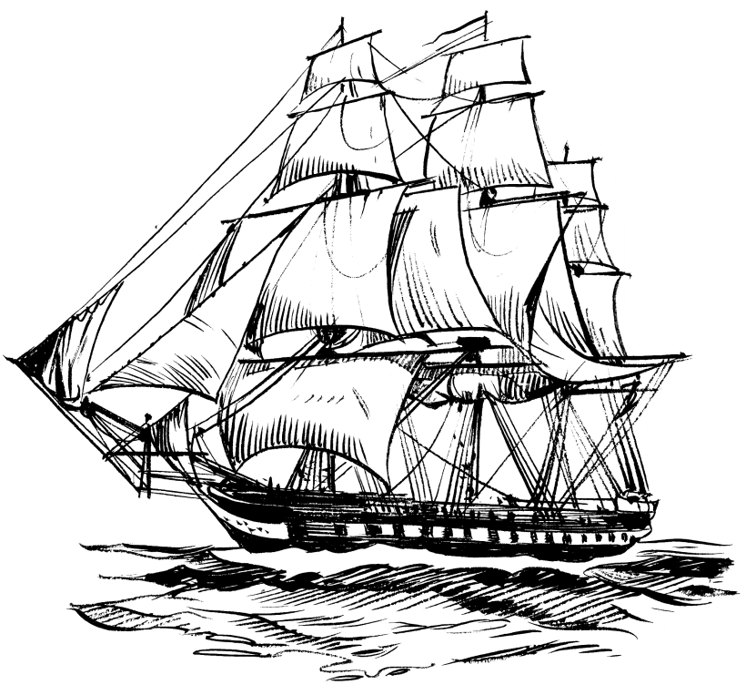
Games and Prizes
Also Happy Birthday USN and USMC



"Duty, honor, country. Those
three hallowed words reverently dictate
what you ought to be, what you can be,
what you will be."
- General Douglas MacArthur

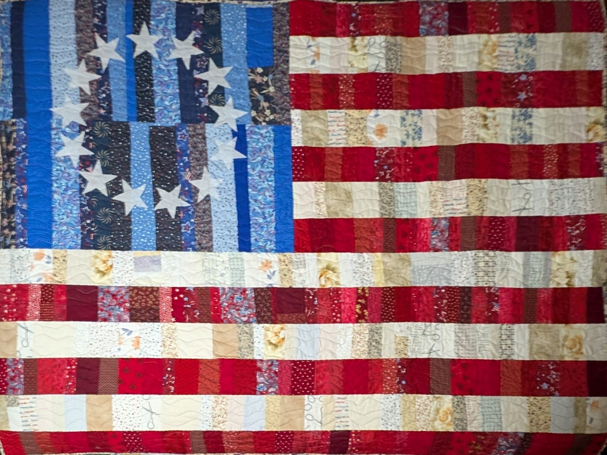

EC Regional Convention Fundraiser
Grand Prize Hand Crafted Quilt
Celebrating our Nation’s 250th Birthday
Raffle $1 each or 6 for $5
More than 25 prizes
Grand Prize Hand Crafted Quilt

Raffle tickets please contact PRPEC Gabriel Falu (757)-581-8390 or Email: gabrielfalufra99@aol.com

Please make checks payable to:
FRA 2026 East Coast Regional Convention

